Program 1:

// Program to swap two numbers using temporary variable

#include<stdio.h>
int main(){
int num1,num2,temp;
printf("Enter Two Numbers:\n");
scanf("%d %d",&num1,&num2);

printf("\nThe Value of Num 1 is: %d\nThe Value of Num 2 is: %d\n",num1,num2);

temp=num1;
num1=num2;
num2=temp;

printf("\nThe Value of Num 1 after swap is: %d\nThe Value of Num 2 after swap is: %d\ n",num1,num2);
}

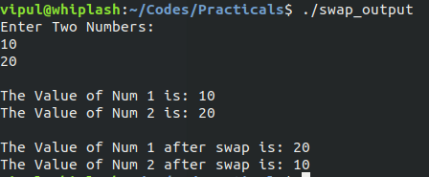

Program 2:

// Program to swap two numbers without using temporary variable

#include<stdio.h>
int main(){
int num1,num2;
printf("Enter Two Numbers:\n");
scanf("%d %d",&num1,&num2);

num1=num1+num2;
num2=num1-num2;
num1=num1-num2;

printf("\nThe Value of Num 1 after swap is: %d\nThe Value of Num 2 after swap is %d\n",num1,num2);
}

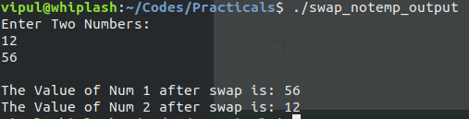

Program 3:

// Program to Convert Temperature from Celcius to Fahrenheit

#include<stdio.h>
int main(){
float celcius,fahrenheit;
printf("Enter Temperature in celcius:\n");
scanf("%f",&celcius);
fahrenheit=(celcius*9/5)+32;
printf("\nThe temperature in fahrenheit= %f\n",fahrenheit);
}

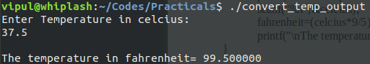

Program 4:

// Program to calculate volume of cylinder

#include<stdio.h>
int main(){
float radius,height,volume;
printf("Enter the radius & height of cylinder:\n");
scanf("%f %f",&radius,&height);

volume=3.14159*radius*radius*height;

printf("\nThe Volume of The Cylinder = %f\n",volume);
}

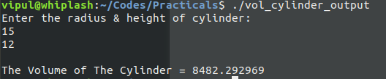

Program 5:

// Program to calculate sum of 5 subjects and calculate percentage

#include<stdio.h>
int main(){
float subjects[5],sum=0,percentage;
printf("Enter marks of 5 subjects:\n");
for(int i=0;i<5;i++){
scanf("%f",&subjects[i]);
sum+=subjects[i];
}
percentage=sum/5;

printf("\nThe Sum of the 5 subjects = %f\nThe Percentage = %f\n",sum,percentage);
}

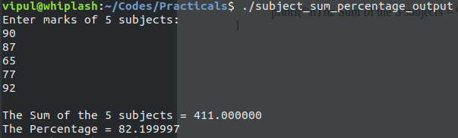

Program 6:

// Program to input distance between two cities in km. and convert to meters and centimeters

#include<stdio.h>
int main(){
float distance,meters,centimeters;
printf("Enter the distance between two cities in km:\n");
scanf("%f",&distance);

meters=distance*1000;
centimeters=meters*100;

printf("\nThe Distance in meters= %f\nThe Distance in cenimeters= %f\n",meters,centimeters);
}

